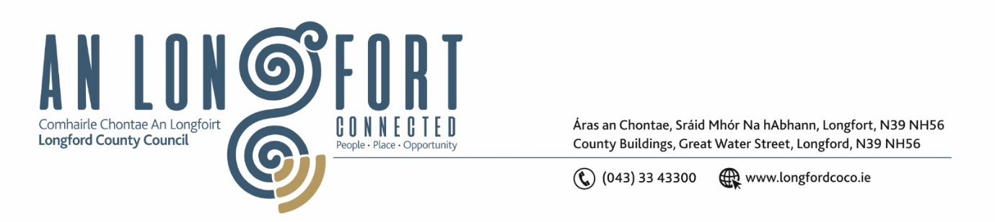

**LONGFORD MUNICIPAL DISTRICT**

***Please note meeting will be held in the Council Chamber, Aras an Chontae and via Microsoft Teams***

**17 April 2024**

**To: Each Member of Longford Municipal District.**

**Dear Member,**

You are requested to attend the Meeting of Longford Municipal District to be held in **the Council Chamber, Aras an Chontae** and **via Microsoft Teams** on **Wednesday 24 April 2024 at 10am** to transact business, as set out on the agenda hereunder.

**Yours sincerely**,

_______________

**Claire McNabola**

**Meetings Administrator**

**AGENDA**

Prayer before meeting.

**1.** Confirmation of Minutes:

1. Longford Municipal District Meeting held on Wednesday 27 March 2024 – enclosed.
2. Longford Municipal District Committee Meeting held on Wednesday 27 March 2024 – enclosed.

**2.** Matters arising from Minutes.

**3.** Declaration of Interest by Members.

**4.** Management Report – enclosed

**5**. Women’s Regional Caucus Safety Walking Audit Report

**6.** Correspondence

1. Response received from Irish Water

7. General

1. **Notice of Motion set out hereunder:**
2. **Councillor Uruemu Adejinmi & Councillor Seamus Butler**

We are Calling on Longford County Council to examine the feasibility of installing a columbarium wall facility in a suitable Clondra/ Killashee district graveyard where cremated remains can be immured, allowing people’s remains to be laid to rest in the locality.